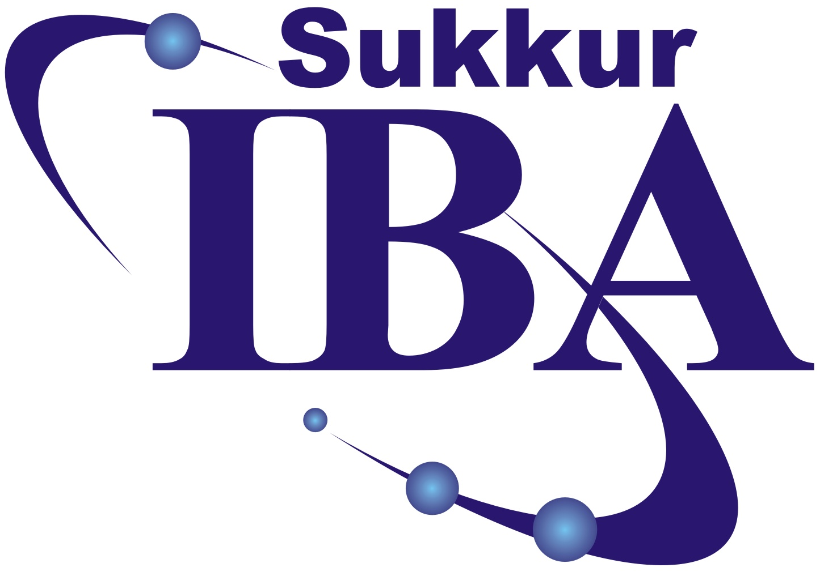 | Sukkur IBA University
Department of Computer Science

Course Title: Applied Physics

Programs & Class: BSCS-II | Semester: 2nd
Credit Hours: 03 (02+01) | Instructor: Dr Abdul Qadir
Office location: Block 03, Room 103, Ext 4053 | Post-requisite Courses:  Electronic devices and circuits
Consulting hours: Monday 12:00 to 1:00pm, Friday 10:00 to 12:00am | e-mail: aqadir@iba-suk.edu.pk

EVALUATION
1. | Quizzes | 10%
2. | Assignment | 10%
3. | Midterm | 30%
5. | Final Examination | 50%

RECOMMENDED BOOKS:
S.No | Book Name | Author/s Name | Publisher Name & Edition
1. | Fundamentals of Physics | David Halliday, Robert Resnick, and Jearl Walker | Ninth Edition, John Wiley & Sons, ISBN: 0471465097.
2. | Electronic devices | Thomas L. Floy d | Ninth Edition, Pearson Education Instruction

REFERENCE BOOKS:
1. | Schaum's Outline of Applied Physics | Arthur Beiser | Fourth Edition, McGraw-Hill, ISBN: 0071426116

DIGITAL & WEB RESOURCES:
www.physicsclassroom.com
www.physicsforum.com

COURSE DESCRIPTION:
Electrostatics: electric charge quantization, charge conservation, Coulomb’s law, first and second shell theorem and their daily life application, electric field and potential, electric field due to charged disk, dipole in electric field, Equipotential surface, Gauss’s law, Applying Gauss' Law: Cylindrical Symmetry, Planar Symmetry, Spherical Symmetry, Capacitance of parallel plate, cylindrical, spherical capacitors, RC circuit, Capacitive time constant, Kirchhoff current law, Kirchhoff voltage law, Multiloop circuits, dielectrics. Electrodynamics: Magnetic field and force, sources of magnetic field, crossed fields: Hall effect, Torque on current carrying loop, Electromagnetic induction, Inductance, Faradays law and lens’s law, Induction and energy transfer, RL circuit, Solid-state physics: Crystal lattices, unit cells, energy bands, allowed and forbidden states, conductors, semiconductors, insulators. Semiconductors: Composition, purity, n- and p-type materials, carrier properties and distribution. Carrier action: Diffusion, drift, generation, recombination. Conductivity, mobility, p-n junction diode, diode curve, forward-biased diode, reverse-biased diode, Half and full wave rectification, Working of NPN transistor, Heat and Thermodynamics, The first law of thermodynamics, Some special cases of first law of thermodynamics, show that PV^{ɣ} = constant, second law of thermodynamics, Carnot cycle, efficiency of Carnot heat engine. Coefficient of performance of refrigerator.
COURSE OBJECTIVES:
- Students will learn principles of physics and how to apply them in different specialties of electrical engineering and energy systems engineering.
- Students will develop writing skills, how to present concepts and describe scientific phenomenon in lucid and simple manners.
- An ability to design simple engineering experiments, analyze and interpret data.
COURSE LEARNING OUTCOMES:
After completion of the course, students should be able to:
CLO1: Understand the relationship between electrical charge, electrical field and electrical potential. Solve numerical problems involving topics covered
CLO2: Apply the principles of electricity and magnetism in a wide range of applications.
CLO3: Apply the knowledge of Resistors, Capacitors, Inductors & Diodes to design circuits based on these basic electronic components.
Curriculum Mapping

CLOs | Related PLOs | Teaching Methods | CLOs attainment checked in | Cog level
1 | 1 | Lectures, tutorials, assignments and numerical sheets | First mid, Second mid, Quiz, final exam | 1
2 | 2 | Lectures, tutorials, assignments and numerical sheets, | First mid , Second mid, final exam, Quiz | 2
3 | 3 | Lab Demonstration | Lab MID I and II, Lab Final Exam. | Psychomotor 3

IMPORTANT POLICIES
The student is expected to attend all of the scheduled classes if for some reason the student cannot make a class I should be contacted in advance, if possible, to arrange to turn in class work and to get assignments or related work, if any, for following class. The course will include homework problems, two midterm exams and a comprehensive final. The student is expected to turn in all work on time.
SESSION / WEEK WISE DETAILS:

Session No. | Week | Topics | Assignments/  Quizzes / Digital Library work | Suggested Readings
01-6 | 03 | Series Parallel Resistors & Capacitors, Voltage Divider, Current Divider  Electric Current, energy transfer in an electric circuit.  Use of Kirchhoff's Ist & 2nd law, capacitance, dielectrics.  Growth and Decay of voltage in an RC circuit.  Solve numerical problems involving topics covered |  | Text book[1]
7-21 | 04 | Electrostatics: Coulomb’s law, first and second shell theorems, Charge in isolated conductors, charge quantization, charge conservation  Electric field and potential, Field due to a point charge: electric field of Dipole,  Electric flux: Gauss's law; and its application, field near a charged conducting sheet, Field of infinite line of charge.  Solve numerical problems involving topics covered | Quiz | Text book [1]
29-34 | 03 | Electrodynamics: Magnetic field and force, sources of magnetic field,  Magnetic force on a charged particle, magnetic force on a current, Torque on a current loop.  Faradays law of electromagnetic induction, Lenz’s law, Magnetic dipole: Energy of magnetic dipole in field.  RL circuit. Solve numerical problems involving topics covered | Quiz II | Text book [1]
41-45 | 04 | Basic crystal structure, free electron model, energy band in solid and energy gaps, doping, p-type, n-type semiconductor materials, p-n junction diode, its structure. Characteristics curve of a diode, half wave rectification, full wave rectification, peak inverse voltage in case of full wave rectifier, characteristics and application as rectifiers. Clipper and clamper circuits. Transistor, its basic structure and operation. Solve numerical problems | Quiz III | Text book [2]

